Smart Research Collaboration & Idea Incubator Platform

INTRODUCTION
The Smart Research Collaboration & Idea Incubator Platform is a versatile and user-friendly full-stack web application designed to streamline the submission, discovery, and collaboration of research and startup ideas within a college community. Suitable for students, researchers, and innovators, it offers a comprehensive set of features — including idea submission, category-based browsing, interest expression, collaboration requests, and threaded comments — all accessible through an intuitive and responsive interface built with React and Tailwind CSS.

Users can register, set up a profile, and immediately begin sharing and exploring ideas. Robust authentication using JWT ensures that data remains secure and access-controlled. The platform integrates MongoDB Atlas for scalable cloud storage of ideas, users, and comments. With built-in search and filter capabilities, pagination, and real-time state management via Zustand, the platform provides an efficient and engaging experience for anyone looking to collaborate on the next big idea.

SCENARIO BASED CASE STUDY
Meet Priya, a third-year computer science student with a strong interest in social entrepreneurship. Priya has an innovative idea for a mobile application that connects local farmers directly with urban consumers, but she lacks the team and resources to bring it to life.

Priya discovers the Idea Incubator Platform at her college — a web application specifically designed to help students like her share ideas, find collaborators, and get feedback from peers across departments.

User Registration and Authentication: Priya creates an account on the platform, filling in her name, email, department, and a short bio. She logs in securely using her credentials, and her session is managed via JWT tokens, ensuring her data stays private.

Browsing and Discovering Ideas: Priya explores the home feed and discovers a variety of ideas across categories like Tech, Business, Social, and Science. She uses the search bar and category filters to narrow down ideas related to agriculture and social impact.

Submitting an Idea: Priya submits her farmer-consumer app idea, adding a detailed description, selecting the "Social" category, and tagging it with relevant keywords. The idea is immediately visible to the college community.

Expressing Interest and Collaborating: A developer named Rohan spots Priya's idea and clicks "Express Interest." Priya sees the interest count rise and can view the profiles of interested users to find potential collaborators.

Commenting and Feedback: A faculty mentor leaves a comment with suggestions on the idea's feasibility. Priya responds in the thread, building a discussion that attracts even more collaborators.

User Profile: Priya visits her profile to see all the ideas she has submitted, the ideas she has saved, and updates her bio to reflect her growing interests.

Priya's Experience: Thanks to the Idea Incubator Platform, Priya found a technical co-founder, received valuable feedback from faculty, and transformed her raw concept into an active project. The platform became her go-to space for ideation, networking, and collaboration within the college.

SYSTEM REQUIREMENTS

Software Requirements
To ensure smooth development, deployment, and usage of the Idea Incubator Web Application, certain system prerequisites must be met. These requirements are categorized into software, setup, and hardware specifications, all of which contribute to building a robust and scalable platform.

1. Software Requirements

These are the essential tools and platforms required to develop, test, and run the application efficiently.

- Operating System: Windows 10/11, macOS, or Linux — Supports cross-platform development and testing.
- Node.js (v16 or above): Provides the runtime environment for the frontend build tooling (Vite) and powers the server-side Express.js logic and API routing.
- npm (v8 or above): A package manager required to install dependencies for React, Express, and related libraries.
- React.js (v19): A JavaScript library for building dynamic and responsive user interfaces using component-based architecture.
- Vite: Lightning-fast frontend build tool and development server used to run the React application.
- Browser: Google Chrome / Firefox (latest version) — For rendering and testing the UI in real-time.
- Express.js: A lightweight web framework for building RESTful APIs on the Node.js backend.
- MongoDB Atlas: A cloud-hosted NoSQL database used to store users, ideas, and comments.
- Mongoose: An ODM (Object Data Modeling) library that provides schema-based data modeling for MongoDB.
- Postman: Tool for testing and debugging API endpoints during development.
- Visual Studio Code: Preferred code editor with built-in Git and terminal support.

2. Hardware Requirements

Describes the minimum and recommended specifications needed to support the development and usage of the application.

- Processor: Intel Core i5 (8th Gen or above) / AMD Ryzen 5 or better — Ensures fast compilation and multitasking during development.
- RAM: Minimum 8 GB (16 GB recommended) — For handling development servers, IDEs, and browser testing simultaneously.
- Storage: At least 1 GB free space — Required for package installations, project files, and local environment setup.
- Display: 1366x768 or higher — Recommended for optimal coding experience and application layout visualization.
- Internet Connection: Required for MongoDB Atlas cloud database access and npm package installation.

PROJECT ARCHITECTURE

Technical Architecture
The Idea Incubator follows a standard MERN stack architecture (MongoDB, Express.js, React.js, Node.js), organized as a client-server model with a clear separation of concerns.

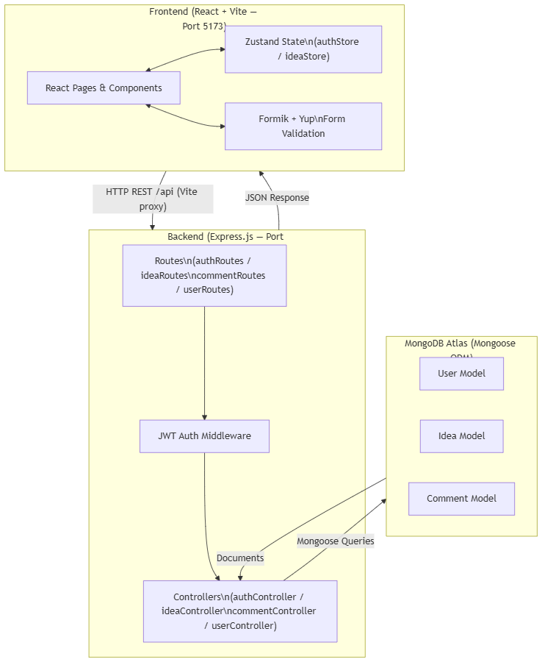

Flow Description:

1. The React frontend (port 5173) sends HTTP requests to /api endpoints, proxied to the backend at localhost:5000 during development.
2. The Express router matches the request to the correct route file and passes it through the JWT Auth Middleware for protected endpoints.
3. Controllers implement the business logic — validating input, running Mongoose queries, and building responses.
4. Mongoose models interact with MongoDB Atlas to persist and retrieve documents.
5. Responses return as JSON to the React frontend, where Zustand stores update global state and re-render the UI.

ER DIAGRAM
The Entity-Relationship diagram for the Idea Incubator represents the core entities and their relationships within the platform's MongoDB database.

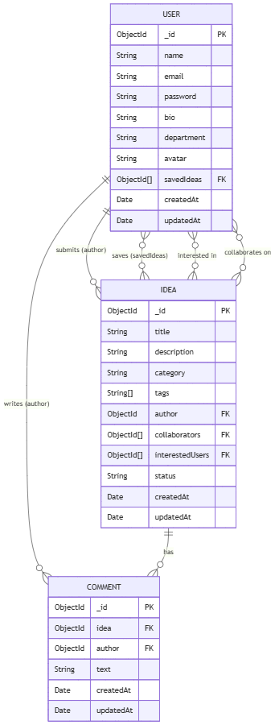

Key Points:

- Primary Keys: Each entity uses MongoDB's auto-generated _id (ObjectId).
- User → Idea: One user can author many ideas; one user can save, be interested in, or collaborate on many ideas (many-to-many via embedded arrays).
- User → Comment: One user can write many comments.
- Idea → Comment: One idea can have many comments; each comment belongs to exactly one idea.
- Foreign Keys: Mongoose ObjectId ref fields link collections — Idea.author → User._id, Comment.idea → Idea._id, Comment.author → User._id.

KEY FEATURES
The key features of the Idea Incubator Platform are designed to foster collaboration, knowledge sharing, and innovation within a college environment:

- User Registration & Authentication: Allow students to create accounts with name, email, department, and bio. Secure login via JWT tokens with protected route access.
- Idea Submission: Users can submit new ideas with a title, detailed description, category (Tech, Business, Social, Science, Art, Other), tags, and status. Formik + Yup ensures validated input.
- Idea Browsing & Discovery: Browse all submitted ideas on the home feed with pagination. Only authenticated users can access the idea browsing feature.
- Search & Filter: Search ideas by keyword and filter by category, tags, or status. State is managed via ideaStore using Zustand.
- Express Interest & Collaborate: Authenticated users can express interest in an idea or request to collaborate. Interest counts and collaborator lists are tracked on each idea.
- Comments & Discussion: Threaded commenting on ideas allows for peer feedback, mentorship, and community discussion.
- User Profiles: Each user has a profile page showing their submitted ideas, bio, and department. Users can edit their profile information.
- Idea Management: Authors can edit or delete their own ideas, including updating the idea's status (open → in-progress → completed) via the edit form.
- Protected Routes: All content-related routes are protected — unauthenticated users are redirected to the login page.

ROLES AND RESPONSIBILITIES

User (Student / Researcher)
- Registration & Account Management: Users are responsible for creating an account, providing accurate information (name, email, department, bio), and keeping their profile up to date.
- Idea Submission: Users can submit new ideas with complete and accurate descriptions, appropriate categories, and relevant tags to maximize discoverability.
- Browsing & Collaboration: Users can browse ideas, express interest, and request collaboration. They are responsible for engaging respectfully and constructively.
- Commenting: Users are expected to provide honest, constructive, and relevant feedback on ideas through the comment system.
- Profile Management: Users maintain their profile information, including bio and department, to help other users understand their background and interests.
- Idea Management: Idea authors are responsible for keeping their ideas updated — editing descriptions and updating status as progress is made.

Admin
- System Management: The admin is responsible for the overall management and health of the platform, including monitoring performance and ensuring data integrity.
- User Management: The admin can manage registered user accounts, including handling any account issues that arise.
- Content Moderation: The admin ensures the quality and appropriateness of submitted ideas and comments on the platform.

USER FLOW

Student / User Flow
Register / Login
|
v
Home Page (Browse Ideas with Search & Filter + Pagination)
|
v
View Idea Detail (Comments, Collaborators, Interest Count)
|
+---> Express Interest / Collaborate
|
+---> Post a Comment
|
v
Submit a New Idea (Create Idea Page)
|
v
Edit / Delete Own Idea (Edit Idea Page)
|
v
View / Update Profile (Profile Page)

Student Flow Summary:
- Register & Login — Create account and authenticate securely.
- Browse Ideas — Discover ideas via feed, search, and category filters.
- Engage — Express interest, collaborate, and comment on ideas.
- Submit — Share original research or startup ideas.
- Manage — Edit idea status and update profile as the project progresses.

Admin Flow Summary:
- System Management — Monitor platform performance and settings.
- User Management — Verify, manage, or moderate user accounts.
- Content Management — Ensure quality and relevance of ideas on the platform.

MVC PATTERN
The Idea Incubator backend follows the Model-View-Controller (MVC) architectural pattern, a software design approach that separates an application into three interconnected layers. This separation allows for modularity, easier maintenance, and scalability.

Model Layer (Data Layer)
The Model layer handles all data-related logic. It defines the structure of stored data and the operations performed on the MongoDB database using Mongoose schemas. Three models are defined:

- User.js — Schema for user accounts (name, email, password, bio, department, savedIdeas)
- Idea.js — Schema for ideas (title, description, category, tags, author, collaborators, interestedUsers, status)
- Comment.js — Schema for comments (idea reference, author reference, text)

Controller Layer
The Controller layer acts as an intermediary between the routes and the models. It receives incoming requests, processes inputs (including validation via validators/), calls appropriate Mongoose model methods, and returns JSON responses to the client.

- authController.js — Handles user registration, login, and JWT token generation.
- ideaController.js — Handles CRUD operations for ideas, plus interest and collaboration logic.
- commentController.js — Handles creating, reading, and deleting comments.
- userController.js — Handles fetching and updating user profiles.

View Layer (Routing Layer)
In the context of this REST API backend, the View is implemented as the routing layer. Each route file defines API endpoints and maps them to the corresponding controller functions.

- authRoutes.js — Routes for /api/auth (register, login)
- ideaRoutes.js — Routes for /api/ideas (CRUD, interest, collaborate)
- commentRoutes.js — Routes for /api/comments
- userRoutes.js — Routes for /api/users (profile read/update)

Advantages of Using MVC in This Project
- Separation of Concerns: Each layer has a clearly defined responsibility, improving readability and maintainability.
- Scalability: New features can be added by creating new routes, controllers, and models without disrupting existing code.
- Reusability: Controller and model logic can be reused across multiple endpoints.
- Testability: Each layer can be tested independently — controllers and models are especially testable in isolation.
- Collaboration-Friendly: Multiple developers can work on different layers simultaneously without conflict.

PROJECT SETUP AND CONFIGURATION

Creating the Project Folder
1. Create a new folder named idea-incubator (or your project name).
2. Inside, create two sub-folders: frontend and backend.
3. Open the root folder in VS Code.

Frontend Setup (React + Vite)
Open the frontend folder in the VS Code terminal:

npm create vite@latest . -- --template react

Select React as the framework and JavaScript as the variant. Then:

npm install
npm install react-router-dom zustand formik yup axios
npm install -D tailwindcss @tailwindcss/vite
npm run dev

The React development server will start at http://localhost:5173.

Configure the Vite proxy in vite.config.js to forward /api requests to the backend:

server: {
proxy: {
'/api': 'http://localhost:5000'
}
}

Backend Setup (Node.js + Express)
Open the backend folder in the VS Code terminal:

npm init -y
npm install express mongoose bcryptjs jsonwebtoken dotenv cors express-validator
npm install -D nodemon

Create the following file and folder structure:

backend/
├── server.js
├── .env
├── config/
│ └── db.js
├── controllers/
│ ├── authController.js
│ ├── ideaController.js
│ ├── commentController.js
│ └── userController.js
├── middleware/
│ └── authMiddleware.js
├── models/
│ ├── User.js
│ ├── Idea.js
│ └── Comment.js
├── routes/
│ ├── authRoutes.js
│ ├── ideaRoutes.js
│ ├── commentRoutes.js
│ └── userRoutes.js
└── validators/

Start the backend server:

npm run dev

The Express server runs at http://localhost:5000.

BACKEND DEVELOPMENT

Backend Structure
backend/
├── controllers/
│ ├── authController.js → Registration, login, JWT issuance
│ ├── ideaController.js → Idea CRUD, interest, collaboration
│ ├── commentController.js → Comment creation and retrieval
│ └── userController.js → Profile fetch and update
├── config/
│ └── db.js → MongoDB Atlas connection setup
├── middleware/
│ └── authMiddleware.js → JWT verification middleware
├── models/
│ ├── User.js → User schema/model
│ ├── Idea.js → Idea schema/model
│ └── Comment.js → Comment schema/model
├── routes/
│ ├── authRoutes.js → /api/auth endpoints
│ ├── ideaRoutes.js → /api/ideas endpoints
│ ├── commentRoutes.js → /api/comments endpoints
│ └── userRoutes.js → /api/users endpoints
├── validators/ → Express-validator validation chains
├── utils/ → Utility helpers
└── server.js → App entry point

Controllers
- authController.js → Handles user registration (with bcrypt password hashing) and login (with JWT token generation).
- ideaController.js → Handles all idea-related operations: create, read (with search/filter/pagination), update, delete, express interest, and collaborate.
- commentController.js → Handles creating comments on ideas and fetching comments by idea ID.
- userController.js → Handles fetching user profiles and updating profile information (bio, department, avatar).

Middleware
- authMiddleware.js → Verifies the JWT token from the Authorization header on protected routes. Attaches the decoded user to req.user.

DATABASE DEVELOPMENT

1. Configure MongoDB Atlas
Install Mongoose in your backend project directory:

npm install mongoose

Create Database Connection (config/db.js)
const mongoose = require('mongoose');
const connectDB = async () => {
try {
await mongoose.connect(process.env.MONGO_URI);
console.log('MongoDB Connected');
} catch (error) {
console.error(error.message);
process.exit(1);
}
};
module.exports = connectDB;

Call connectDB() in server.js before starting the Express server.

Create Schemas
1. User.js — Schema for user accounts

const userSchema = new mongoose.Schema({
name: { type: String, required: true, trim: true },
email: { type: String, required: true, unique: true, lowercase: true },
password: { type: String, required: true, minlength: 6 },
bio: { type: String, default: '' },
department: { type: String, default: '' },
avatar: { type: String, default: '' },
savedIdeas: [{ type: mongoose.Schema.Types.ObjectId, ref: 'Idea' }],
}, { timestamps: true });

2. Idea.js — Schema for submitted ideas

const ideaSchema = new mongoose.Schema({
title: { type: String, required: true, trim: true },
description: { type: String, required: true },
category: { type: String, required: true,
enum: ['Tech', 'Business', 'Social', 'Science', 'Art', 'Other'] },
tags: [{ type: String, trim: true }],
author: { type: mongoose.Schema.Types.ObjectId, ref: 'User', required: true },
collaborators: [{ type: mongoose.Schema.Types.ObjectId, ref: 'User' }],
interestedUsers: [{ type: mongoose.Schema.Types.ObjectId, ref: 'User' }],
status: { type: String, enum: ['open', 'in-progress', 'completed'], default: 'open' },
}, { timestamps: true });

3. Comment.js — Schema for idea comments

const commentSchema = new mongoose.Schema({
idea: { type: mongoose.Schema.Types.ObjectId, ref: 'Idea', required: true },
author: { type: mongoose.Schema.Types.ObjectId, ref: 'User', required: true },
text: { type: String, required: true, trim: true },
}, { timestamps: true });

FRONTEND DEVELOPMENT

Frontend Structure
frontend/src/
├── pages/
│ ├── HomePage.jsx → Idea feed with search, filter, pagination
│ ├── IdeaDetailPage.jsx → Full idea view with comments & collaborators
│ ├── CreateIdeaPage.jsx → Form to submit a new idea
│ ├── EditIdeaPage.jsx → Form to edit an existing idea (author only)
│ ├── DashboardPage.jsx → User dashboard overview
│ ├── ProfilePage.jsx → User profile view and edit
│ ├── LoginPage.jsx → User login form
│ ├── RegisterPage.jsx → User registration form
│ └── NotFoundPage.jsx → 404 page
├── components/
│ ├── idea/
│ │ ├── IdeaCard.jsx → Card component for displaying an idea in the feed
│ │ ├── IdeaForm.jsx → Reusable form for create/edit idea (Formik + Yup)
│ │ └── IdeaList.jsx → Renders a list of IdeaCard components
│ ├── comment/
│ │ └── Comment.jsx → Individual comment component
│ ├── common/ → Shared UI elements (buttons, inputs, loaders, etc.)
│ ├── layout/
│ │ ├── Navbar.jsx → Top navigation bar with auth state
│ │ └── Footer.jsx → App footer
├── store/
│ ├── authStore.js → Zustand store for authentication state
│ └── ideaStore.js → Zustand store for ideas, filters, and pagination
├── api/ → Axios API call functions
├── hooks/ → Custom React hooks
├── utils/ → Utility functions
├── App.jsx → Root component with React Router routes
└── main.jsx → Application entry point

Pages
- HomePage.jsx → Main idea browsing feed. Displays paginated ideas with search by keyword and filter by category. Restricted to authenticated users only.
- IdeaDetailPage.jsx → Displays full idea details including description, tags, status, collaborators, interest count, and threaded comments.
- CreateIdeaPage.jsx → Form-driven page for submitting a new idea (title, description, category, tags). Uses Formik + Yup validation.
- EditIdeaPage.jsx → Allows idea authors to update their idea's content and status. showStatus prop enables the status field in edit mode.
- DashboardPage.jsx → User dashboard showing activity overview.
- ProfilePage.jsx → Displays user profile (name, bio, department) and their submitted ideas. Allows profile editing.
- LoginPage.jsx / RegisterPage.jsx → Authentication forms with validation.

Components
- IdeaCard.jsx → Compact card for displaying idea title, category, author, tags, and interest count in the feed.
- IdeaForm.jsx → Reusable Formik form component used on both Create and Edit pages.
- IdeaList.jsx → Renders a grid of IdeaCard components from the ideaStore.
- Navbar.jsx → Responsive navigation bar; shows user name and logout when authenticated.
- Footer.jsx → App footer shown on all pages.

State Management (Zustand)
- authStore.js → Stores the authenticated user object and JWT token. Provides login, logout, and register actions.
- ideaStore.js → Stores the current list of ideas, search/filter state (keyword, category, page), and pagination metadata. Provides fetchIdeas, createIdea, updateIdea, deleteIdea actions.

OUTPUT SCREENSHOTS

Landing Page

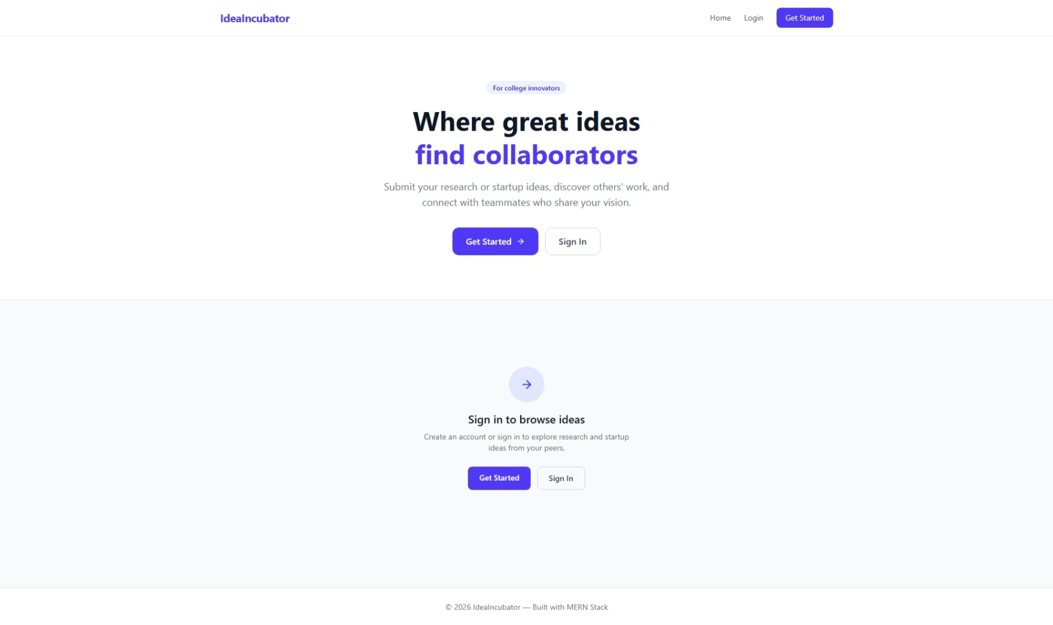

Register Page
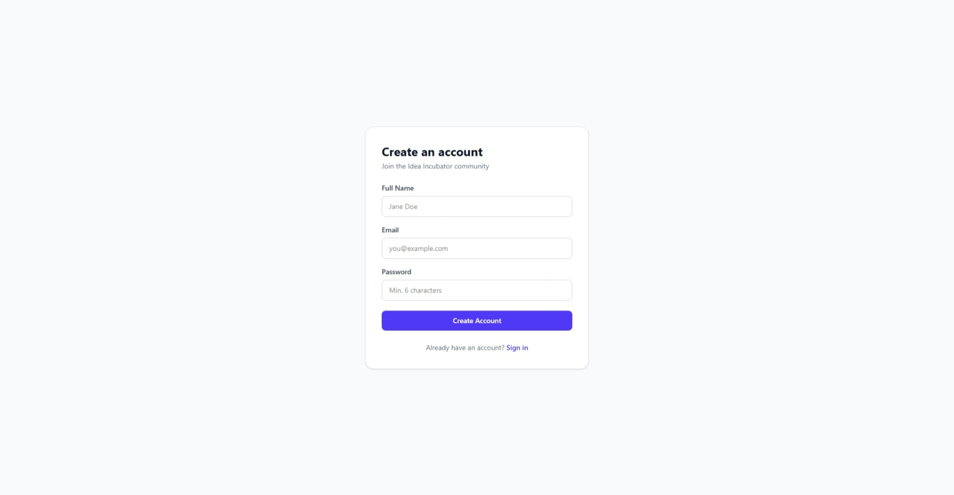

Login Page
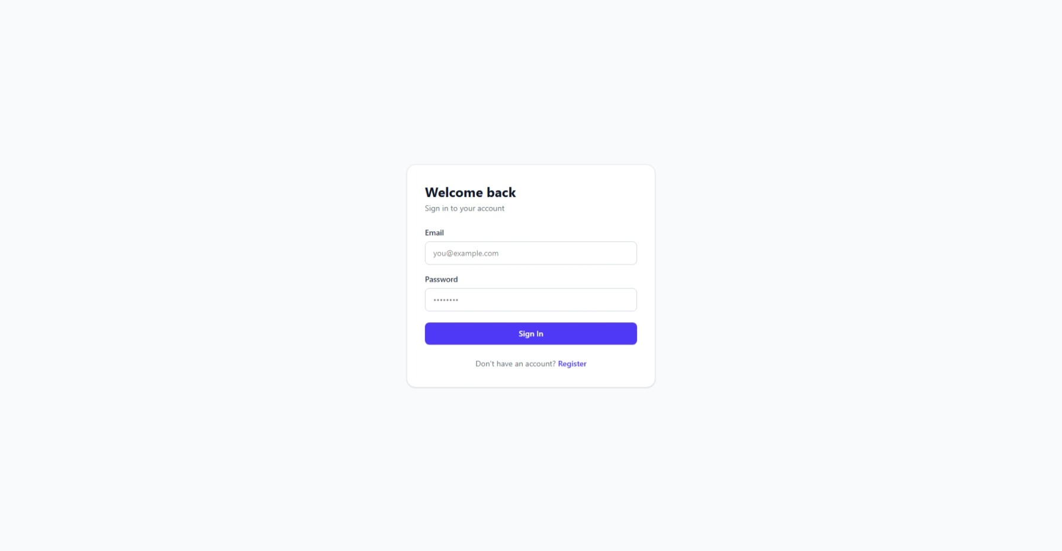

Submit a New Idea Page
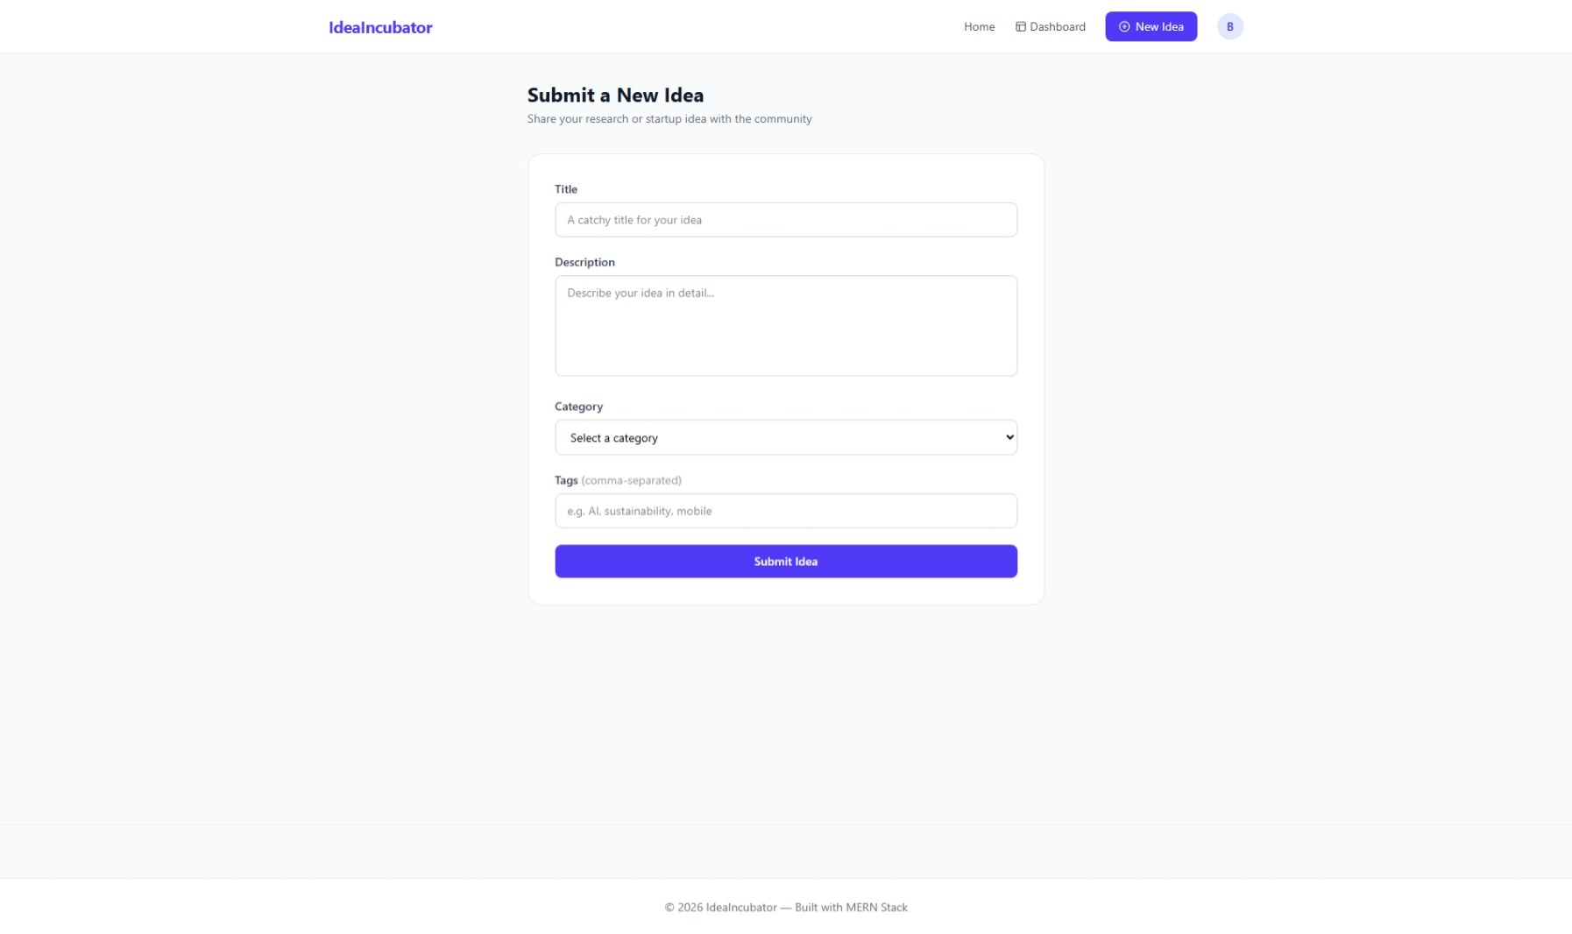

Idea Detail Page
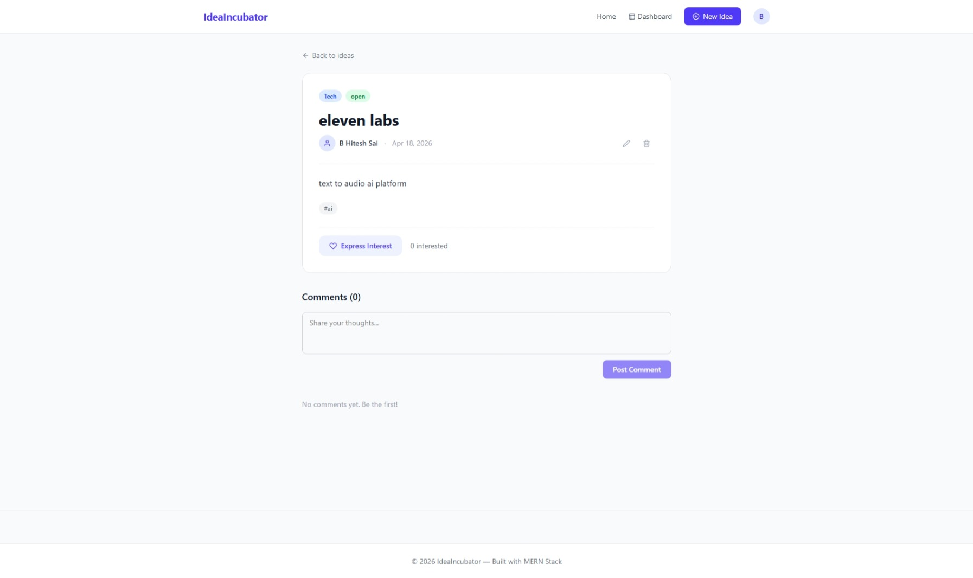

Edit Idea Page
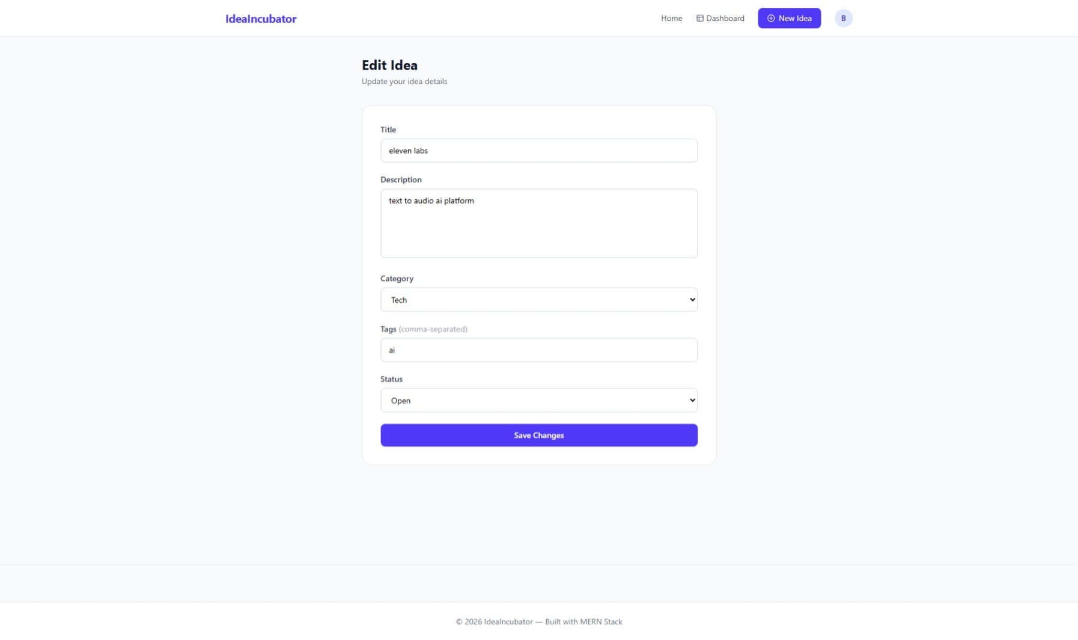

Profile Page
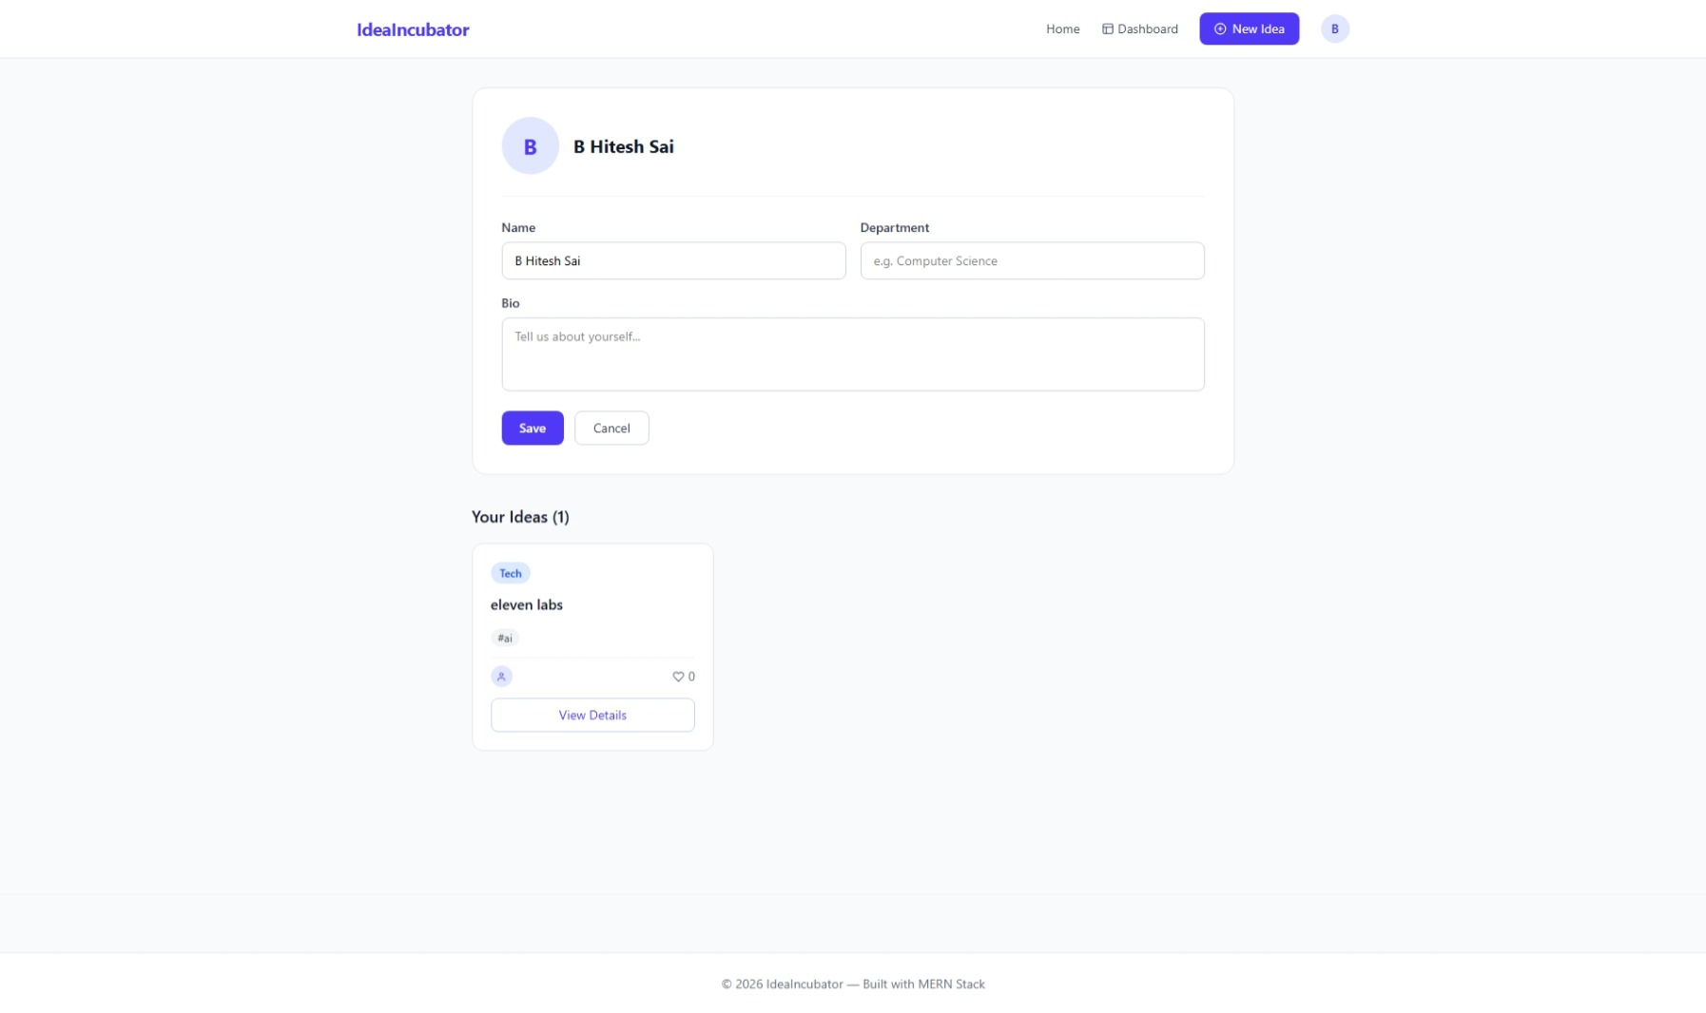

Smart Research Collaboration & Idea Incubator Platform — MERN Stack College Project
Stack: React 19 + Vite + Tailwind CSS v4 + Zustand | Node.js + Express 5 + MongoDB Atlas + JWT

